DL ASSIGNMENT -2

Name: K.Meghana

Roll No:S20160010040

1.

Here,we are generating the similar images to dataset images.

Each image is for each epoch.

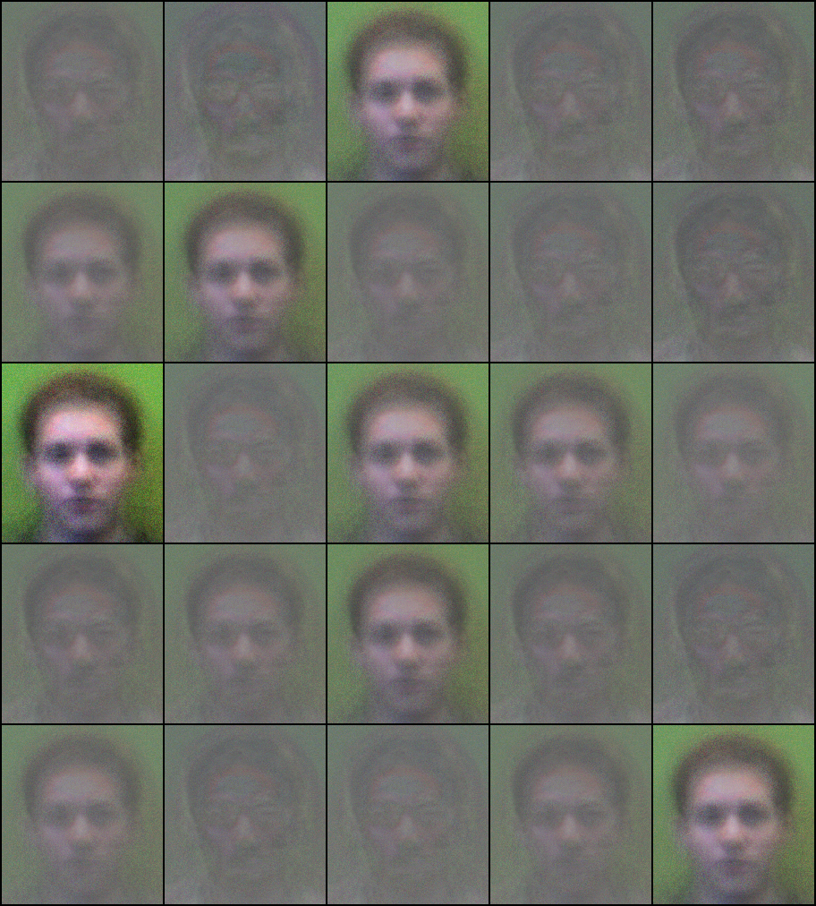

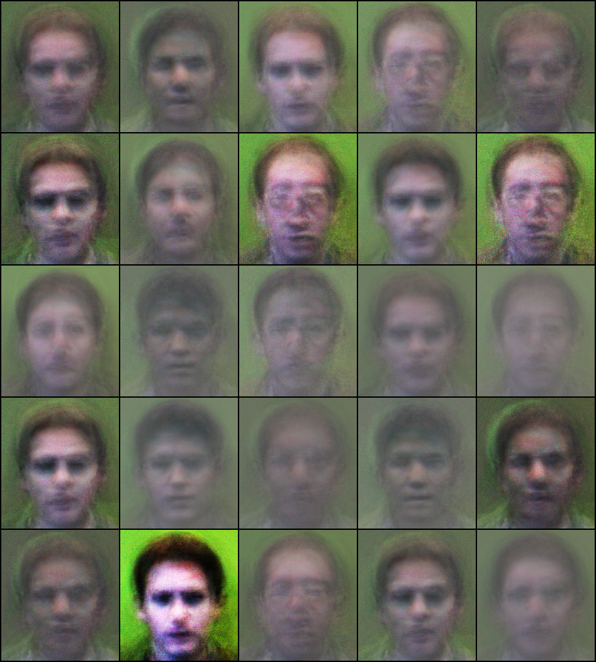

2.The output is csv file which contains latent representation of images with label.

The csv file is attached in the submitted folder.